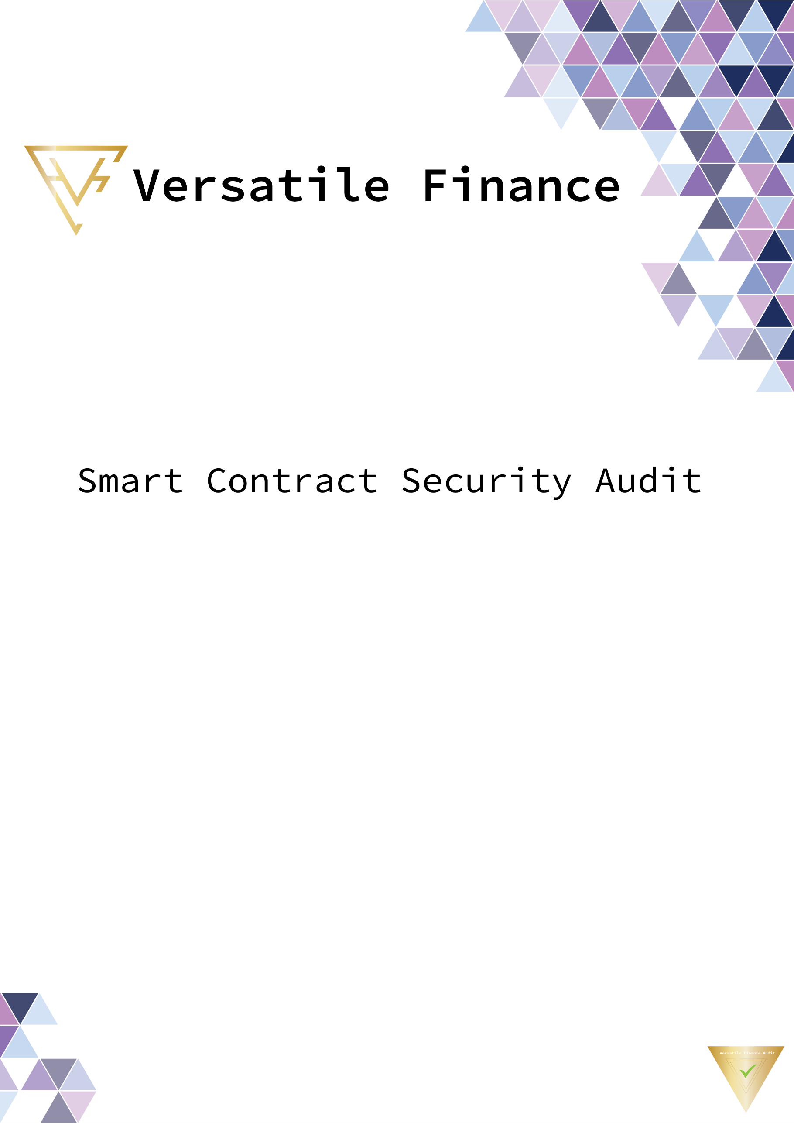



**Eterna Token**

05 November 2022

**Summary**

**Project Name:** Eterna Token

**Contract Address:** 0xE156ef68e42f33B74d23B497e37CE00a74873DBe

**Client contact:** Eterna Team

**Blockchain:** Binance smart chain

**Language:** Solidity

**Project website:** <https://eterna.exchange/>

**Buy Tax:** 0%

**Sell Tax:** 0%

**Token supply:** 1,000,000,000

**Token ticker:** EHX

**Decimals:** 18

**Contract deployer address:** 0x823df60E1acC3637ecC9C2b716cb5E8971EAa783

**Contract’s current owner address:** 0x823df60e1acc3637ecc9c2b716cb5e8971eaa783

**Background**

Versatile Finance was commissioned by Eterna Team to perform an audit of the smart contract.

<https://bscscan.com/address/0x823df60e1acc3637ecc9c2b716cb5e8971eaa783>

The purpose of this audit was to achieve the following:

* Identify potential security issues with smart contracts
* Formally check the logic behind given smart contracts.

Information in this report should be used for understanding the risk exposure of smart contracts, and as a guide to improving the security posture of smart contracts by remediating the issues that were identified.

**What is an audit**

A smart contract audit is a comprehensive review process designed to discover logical errors, security vulnerabilities, and optimization opportunities within code. Versatile Finance manages this a step further by verifying economic logic to ensure the stability of smart contracts and highlighting privileged functionality to create a report that is easy to understand for developers and community members.

**Techniques and Methods**

* The code quality
* Use of best practices
* Implementation of ERC-20 token standards.
* Efficient use of gas.
* Code is safe from re-entrancy and other vulnerabilities.
* Code risk issue analysis and recommendations
* Ownership privileges
* Code documentation and comments match logic and expected behavior.
* Token distribution and calculations are as per the intended behavior mentioned in the whitepaper.

The following techniques, methods, and tools were used to review all the smart contracts.

**Structural Analysis**

We analyze the design patterns and structure of smart contracts. A thorough check is done to ensure the smart contract is structured in a way that will not have any issues.

**Static Analysis**

A static Analysis of Smart Contracts is done to identify contract vulnerabilities. In this step, a series of automated tools and manual testings are used to test the security of smart contracts.

**Code Review / Manual Analysis**

Manual Analysis or review of code is done to identify new vulnerabilities or verify the vulnerabilities found during the static analysis. Contracts is completely manually analyzed line by line, and the logic is checked and compared with what’s mentioned in the whitepaper to make sure everything’s functioned as intended.

**Gas Consumption**

We check the behavior of smart contracts in production. Manual tests are done in DEXs to know how much gas gets consumed and the possibilities of optimization of code to reduce gas consumption.

**Issue Categories**

Every issue in this report has been assigned a severity level. There are four levels of severity and each of them has been explained below.

**High severity issues**

**1 High severity issue found**

The Owner can mint new tokens

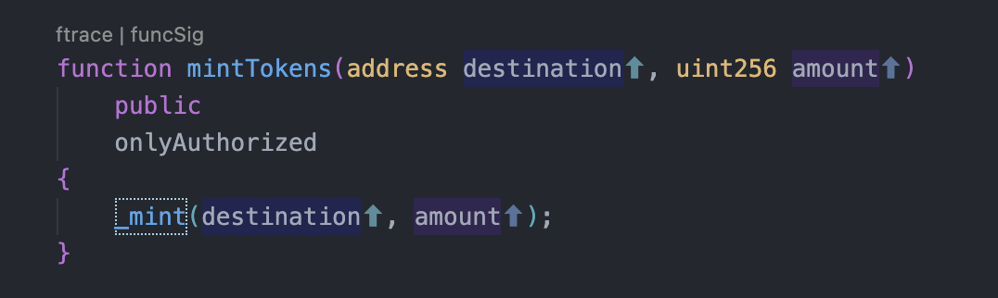

**Medium-level severity issues**

**No Medium severity issues found**

The issues marked as medium severity usually arise because of errors and deficiencies in the smart contract code. Issues on this level could potentially bring problems and they can still be fixed. This can put users' funds at risk and has a medium to high probability of exploitation.

**Low-level severity issues**

**No low severity issues found**

Low-level severity issues can cause minor impact and or are just warnings that can remain unfixed for now. It would be better to fix these issues at some point in the future. These issues have a low probability of occurring or may have a minimal impact.

**Informational**

**No Informational issues found**

These are severity four issues that indicate an improvement request, a general question, a cosmetic or documentation error, or a request for information. There is low-to-no impact.

**Centralization**

**1 Centralization issue found**

The Owner can mint new tokens



**Contracts Description Table**

|  |  |  |  |  |
| --- | --- | --- | --- | --- |
| Contract | Type | Bases |  |  |
| └ | Function Name | Visibility | Mutability | Modifiers |
|  |  |  |  |  |
| Context | Implementation |  |  |  |
| └ | _msgSender | Internal 🔒 |  |  |
| └ | _msgData | Internal 🔒 |  |  |
|  |  |  |  |  |
| IERC20 | Interface |  |  |  |
| └ | totalSupply | External ❗️ |  | NO❗️ |
| └ | balanceOf | External ❗️ |  | NO❗️ |
| └ | transfer | External ❗️ | 🛑 | NO❗️ |
| └ | allowance | External ❗️ |  | NO❗️ |
| └ | approve | External ❗️ | 🛑 | NO❗️ |
| └ | transferFrom | External ❗️ | 🛑 | NO❗️ |
| └ | name | External ❗️ |  | NO❗️ |
| └ | symbol | External ❗️ |  | NO❗️ |
| └ | decimals | External ❗️ |  | NO❗️ |
|  |  |  |  |  |
| ERC20 | Implementation | Context, IERC20 |  |  |
| └ |  | Public ❗️ | 🛑 | NO❗️ |
| └ | name | Public ❗️ |  | NO❗️ |
| └ | symbol | Public ❗️ |  | NO❗️ |
| └ | decimals | Public ❗️ |  | NO❗️ |
| └ | totalSupply | Public ❗️ |  | NO❗️ |
| └ | balanceOf | Public ❗️ |  | NO❗️ |
| └ | transfer | Public ❗️ | 🛑 | NO❗️ |
| └ | allowance | Public ❗️ |  | NO❗️ |
| └ | approve | Public ❗️ | 🛑 | NO❗️ |
| └ | transferFrom | Public ❗️ | 🛑 | NO❗️ |
| └ | increaseAllowance | Public ❗️ | 🛑 | NO❗️ |
| └ | decreaseAllowance | Public ❗️ | 🛑 | NO❗️ |
| └ | _transfer | Internal 🔒 | 🛑 |  |
| └ | _mint | Internal 🔒 | 🛑 |  |
| └ | _burn | Internal 🔒 | 🛑 |  |
| └ | _approve | Internal 🔒 | 🛑 |  |
|  |  |  |  |  |
| Ownable | Implementation | Context |  |  |
| └ |  | Public ❗️ | 🛑 | NO❗️ |
| └ | owner | Public ❗️ |  | NO❗️ |
| └ | renounceOwnership | External ❗️ | 🛑 | onlyOwner |
| └ | transferOwnership | Public ❗️ | 🛑 | onlyOwner |
|  |  |  |  |  |
| Roles | Library |  |  |  |
| └ | add | Internal 🔒 | 🛑 |  |
| └ | remove | Internal 🔒 | 🛑 |  |
| └ | has | Internal 🔒 |  |  |
|  |  |  |  |  |
| AuthorizedRole | Implementation | Ownable |  |  |
| └ | isAuthorized | Public ❗️ |  | NO❗️ |
| └ | addAuthorized | Public ❗️ | 🛑 | onlyOwner |
| └ | removeAuthorized | Public ❗️ | 🛑 | onlyOwner |
| └ | renounceAuthorized | Public ❗️ | 🛑 | NO❗️ |
| └ | _addAuthorized | Internal 🔒 | 🛑 |  |
| └ | _removeAuthorized | Internal 🔒 | 🛑 |  |
|  |  |  |  |  |
| IDexRouter | Interface |  |  |  |
| └ | factory | External ❗️ |  | NO❗️ |
| └ | WETH | External ❗️ |  | NO❗️ |
|  |  |  |  |  |
| IDexFactory | Interface |  |  |  |
| └ | createPair | External ❗️ | 🛑 | NO❗️ |
|  |  |  |  |  |
| EHX | Implementation | ERC20, Ownable, AuthorizedRole |  |  |
| └ |  | Public ❗️ | 🛑 | ERC20 |
| └ | enableTrading | External ❗️ | 🛑 | onlyOwner |
| └ | manageRestrictedWallets | External ❗️ | 🛑 | onlyOwner |
| └ | removeLimits | External ❗️ | 🛑 | onlyOwner |
| └ | setRobinHoodActive | External ❗️ | 🛑 | onlyOwner |
| └ | setRobinHoodPercent | External ❗️ | 🛑 | onlyOwner |
| └ | setRobinHoodAddress | External ❗️ | 🛑 | onlyOwner |
| └ | updateMaxTransaction | External ❗️ | 🛑 | onlyOwner |
| └ | transferForeignToken | External ❗️ | 🛑 | onlyOwner |
| └ | setAutomatedMarketMakerPair | Public ❗️ | 🛑 | onlyOwner |
| └ | setWhitelistedAddress | Public ❗️ | 🛑 | onlyOwner |
| └ | mintTokens | Public ❗️ | 🛑 | onlyAuthorized |
| └ | burnTokens | Public ❗️ | 🛑 | onlyAuthorized |
| └ | _transfer | Internal 🔒 | 🛑 |  |

Legend

|  |  |
| --- | --- |
| Symbol | Meaning |
| 🛑 | Function can modify state |
| 💵 | Function is payable |

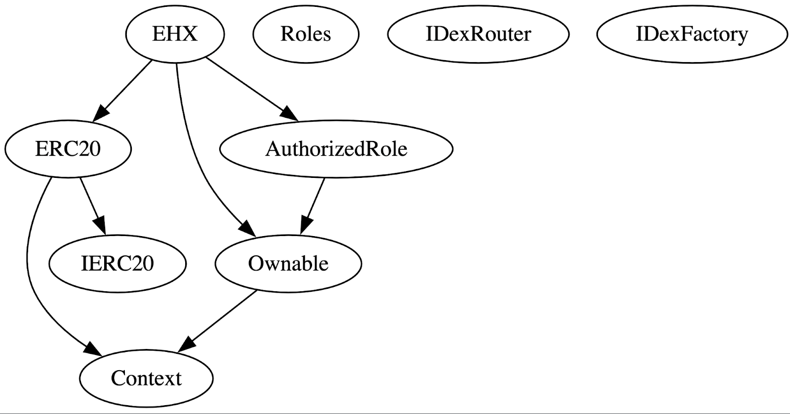

**Owner privileges**

The owner can enable trading, once enabled can not disable again

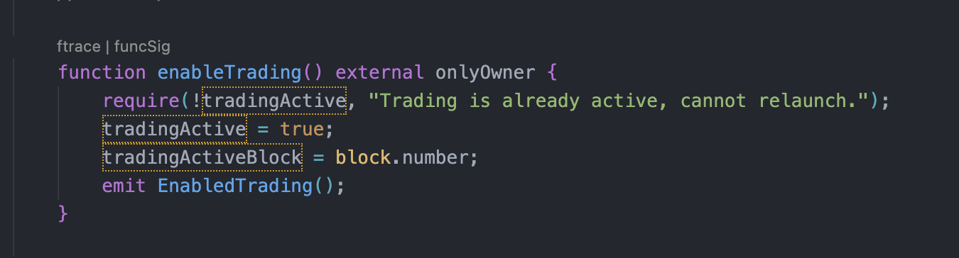

The owner can remove transactions limit, once removed can not enable again

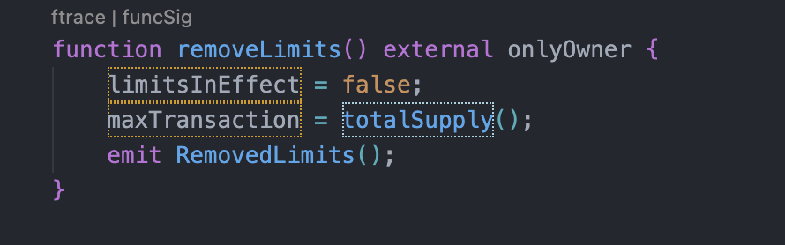

The owner can active/deactivate Robinhood method ( robin hood method is an anti-bot mechanism it will take some extra percentage of tax if someone buys and sell in the same block)

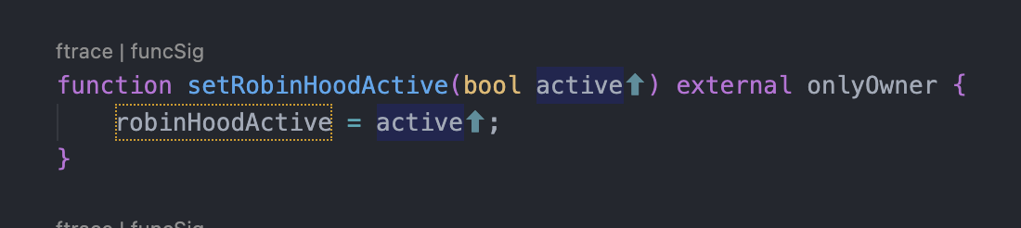

The owner can change robin hood tax percentage

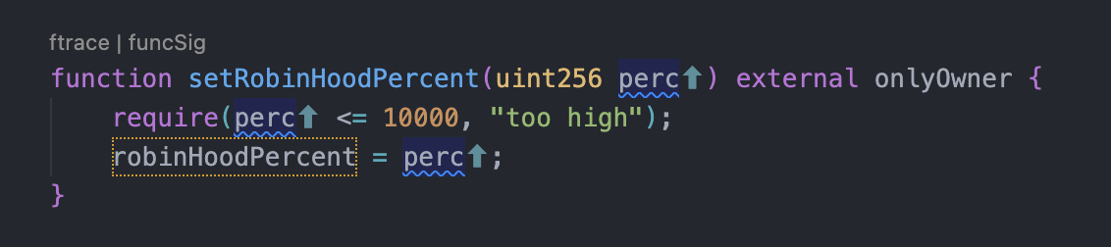

The owner can change robin hood tax receiver address

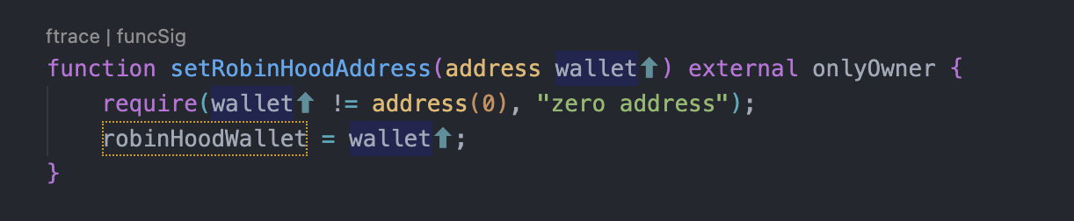

The owner can change max transaction amount minimum up to 0.1%

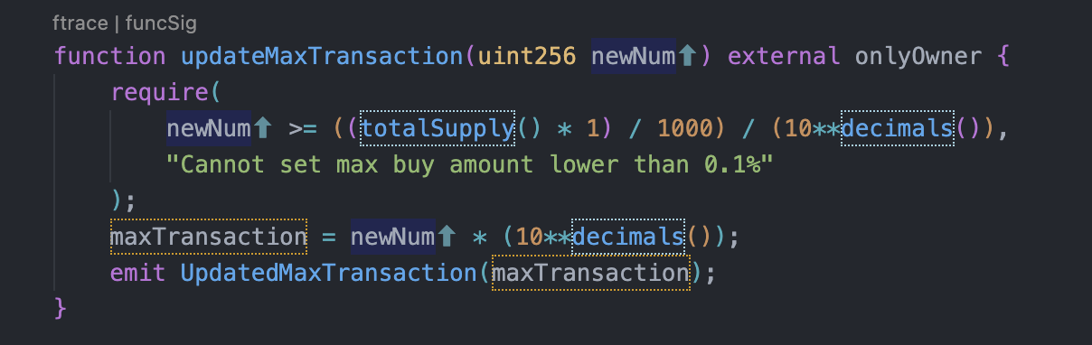

The owner can take any BEP20 tokens from the contract

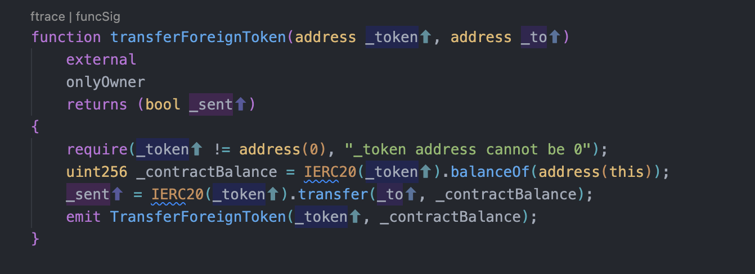

The owner can add any extra LP address

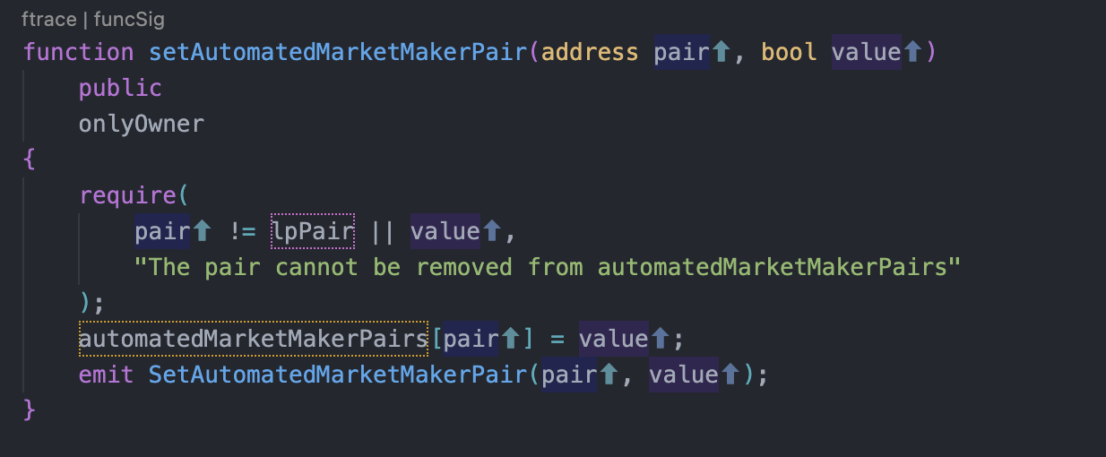

The owner can whitelist and remove addresses

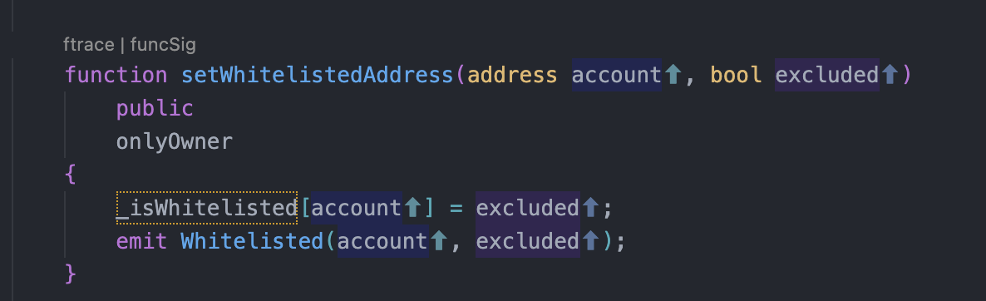

The owner can mint any new tokens



The owner can burn tokens from his wallet

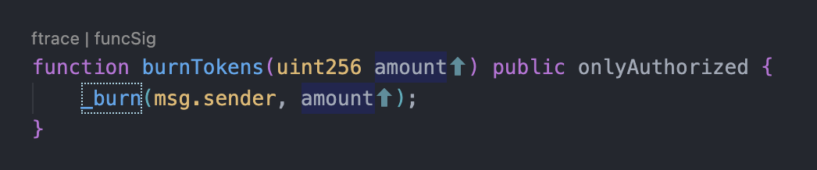

**Audit Results**

|  |  |
| --- | --- |
| **Vulnerability Category** | **Status** |
| Arbitrary Jump/Storage Write | pass |
| BRC20 Token standards | pass |
| Compiler errors | pass |
| Latest compiler version | pass |
| Authorization of function call to untrusted contract | pass |
| Dependence on Predictable Variables | pass |
| Ether/Token Theft | pass |
| Gas consumption | pass |
| Safemath features | pass |
| Fallback usage | pass |
| Deprecated items | pass |
| Redundant code | pass |
| Overriding variables | pass |
| Flash Loans | pass |
| Front Running | pass |
| Improper Events | pass |
| Improper Authorization Scheme | pass |
| Integer Over/Underflow | pass |
| Business logic issues | pass |
| Oracle issues | pass |
| Race Conditions | pass |
| Reentrancy | pass |
| Signature Issues | pass |
| Unbounded Loops | pass |
| Unused Code | pass |
| Pseudo-random number generator (PRNG) | pass |
| Fake deposit | pass |
| Centralisation | **High severity issues** |

**Audit conclusion**

Versatile Finance team has performed in-depth testings, line by line manual code review, and automated audit of the smart contract. The smart contract was analyzed mainly for common smart contract vulnerabilities, exploits, manipulations, and hacks. According to the smart contract audit.

Smart contract functional Status: **PASS**

Number of risk issues: **1**

Solidity code functional issue level: **PASS**

Number of owner privileges: **11**

Centralization risk correlated to the active owner: **HIGH**

Smart contract active ownership: **ACTIVE**

**Disclaimer**

This is a limited report on our findings based on our analysis, in accordance with good industry practice as of the date of this report, in relation to cybersecurity vulnerabilities and issues in the framework and algorithms based on smart contracts, the details of which are set out in this report. In order to get a full view of our analysis, it is crucial for you to read the full report. While we have done our best in conducting our analysis and producing this report, it is important to note that you should not rely on this report and cannot claim against us on the basis of what it says or doesn’t say, or how we produced it, and it is important for you to conduct your own independent investigations before making any decisions. We go into more detail on this in the disclaimer below – please make sure to read it in full.

DISCLAIMER: By reading this report or any part of it, you agree to the terms of this disclaimer. If you do not agree to the terms, then please immediately cease reading this report, and delete and destroy any and all copies of this report downloaded and/or printed by you. This report is provided for information purposes only and on a non-reliance basis and does not constitute investment advice. No one shall have any right to rely on the report or its contents, and Versatile Finance and its affiliates (including holding companies, shareholders, subsidiaries, employees, directors, officers, and other representatives) (Versatile Finance) owe no duty of care towards you or any other person, nor does Versatile Finance make any warranty or representation to any person on the accuracy or completeness of the report. The report is provided "as is", without any conditions, warranties, or other terms of any kind except as set out in this disclaimer, and Versatile Finance hereby excludes all representations, warranties, conditions, and other terms (including, without limitation, the warranties implied by law of satisfactory quality, fitness for purpose and the use of reasonable care and skill) which, but for this clause, might have effect in relation to the report. Except and only to the extent that it is prohibited by law, Versatile Finance hereby excludes all liability and responsibility, and neither you nor any other person shall have any claim against Versatile Finance, for any amount or kind of loss or damage that may result to you or any other person (including without limitation, any direct, indirect, special, punitive, consequential or pure economic loss or damages, or any loss of income, profits, goodwill, data, contracts, use of money, or business interruption, and whether in delict, tort (including without limitation negligence), contract, breach of statutory duty, misrepresentation (whether innocent or negligent) or otherwise under any claim of any nature whatsoever in any jurisdiction) in any way arising from or connected with this report and the use, inability to use or the results of the use of this report, and any reliance on this report. The analysis of the security is purely based on the smart contracts alone. No applications or operations were reviewed for security. No product code has been reviewed.